

SIMATS ENGINEERING

Saveetha Institute of Medical and Technical Sciences Chennai- 602105
Student Name: Ch.Sri Deepika Reg. No.:192424412
Course Code:DSA0613 Slot:A
Course Name: Data Handling and Visualization for Data Analytics
Course Faculty: Dr.Kumargurubaran & Dr.Senthilvadivu S

Project Title: AGRI VISION – CROP PRODUCTION INTELLIGENCE PLATFORM
Module Photographs:
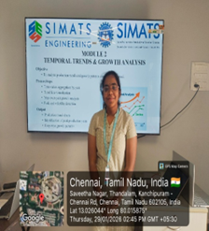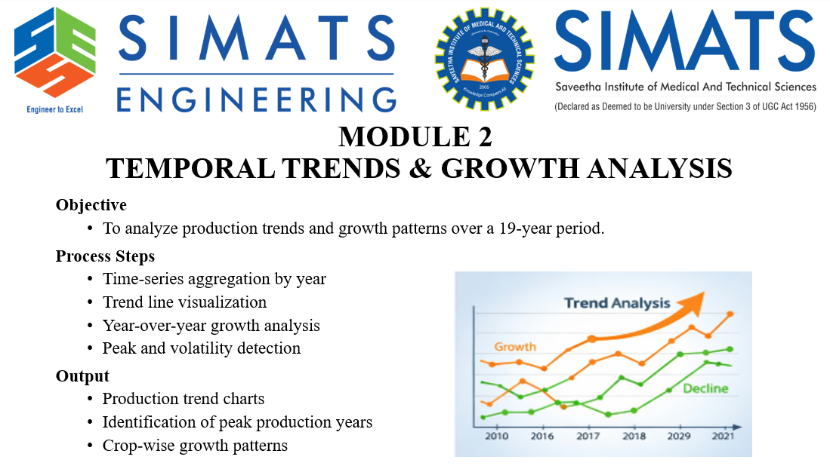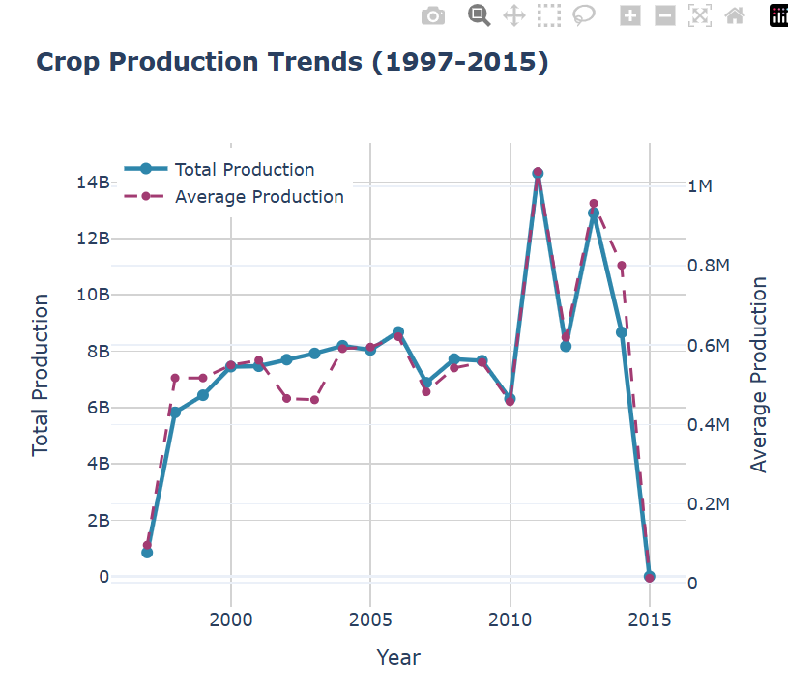
Project Description:
Temporal Trends & Growth Analysis focuses on understanding how agricultural production has evolved over a long-term period using time-series data analysis. The primary objective of this module is to examine production trends and growth patterns over a 19-year timeframe, enabling stakeholders to identify long-term changes, stability, and fluctuations in crop output. By aggregating production data year-wise, the module transforms raw historical records into meaningful temporal insights.

The process involves visualizing trend lines to clearly represent increases, declines, or stagnation in production over time. Year-over-year growth analysis is applied to measure incremental changes between consecutive years, helping to highlight periods of rapid growth or slowdown. Additionally, peak detection techniques are used to identify years with maximum production, while volatility analysis captures irregular fluctuations caused by factors such as climate variability, policy changes, or market conditions.

The outputs of this module include clear and interpretable production trend charts, identification of peak production years, and crop-wise growth patterns across the study period. Overall, this module supports data-driven decision-making by providing a comprehensive temporal perspective, allowing researchers, planners, and policymakers to and plan future agricultural strategies effectively.

Ch.Sri Deepika
Student Signature Guide Signature

